**PIZZA SALES PROJECT**

Introduction :

The pizza industry is rapidly growing market, driven by increasing demand for convenient and affordable food options. With numerous players competing for market share, understanding customer behavior and preferences is crucial for businesses to stay ahead. This project aims to analyze pizza sales data to provide insights into customer behavior, preferences, and trends (daily, monthly and weekly) . By exploring some KPI REQUIREMENT such as popular pizza types and toppings, location-based sales trends, and the impact of seasonal promotions, this project will inform business decisions and optimize sales strategies to drive growth and customer satisfaction.

**KPI REQUIREMENTS :**

We need to analyze key indicators for our pizza sales data to gain insights into our business performance. Specifically ,WE want to calculate the following metrics.

1. TOTAL REVENUE: The sum of the total price of all pizza orders.
2. AVERAGE ORDER VALUE: The average amount spent per order, calculated by dividing the total revenue by the total number of orders.
3. TOTAL PIZZA’S SOLD: The sum of the quantities of all pizzas sold
4. TOTAL ORDER”S: The total number of orders placed
5. AVERAGE PIZZAS PER ORDER: The average number of pizzas sold per order, calculated by dividing the total number of pizzas sold by total number of orders.

For these requirements we used to analyze the data with some tools :

METHOD OF TOOLS USED :

* Python
* Sql
* Power bi

TOTAL REVENUE :[ python method]

#total_revenue = df["total_price"]. sum().

TOTAL ORDERS :

total_orders = df["order_id"].nunique().

TOTAL PIZZA’S SOLD :

total_pizzas_sold = df["quantity"].sum()

AVERAGE PIZZAS PER ORDER :

average_order_value = total_revenue / total_orders

SQL METHOD :

TOTAL REVENUE :

select sum(total_price) AS TOTAL_REVENUE from pizza_sales;

TOTAL ORDERS :

select count(distinct order_id) AS TOTAL_ORDERS from pizza_sales;

TOTAL PIZZA’S SOLD :

select sum(quantity) AS TOTAL_PIZZAS_SOLD from pizza_sales;

AVERAGE PIZZAS PER ORDER :

select (sum(quantity)/count(distinct order_id)) AS AVERAGE_PIZZAS_PER_ORDER from pizza_sales;

AVERAGE ORDER VALUE:

select (sum(total_price)/count(distinct order_id)) AS AVERAGE_ORDER_VALUE from pizza_sales

**POWER BI METHOD**

TOTAL ORDERS :

* total no of orders = COUNT(pizza_sales[order_id])
* average pizzas per order = sum(pizza_sales[quantity])/count(pizza_sales[order_id])
* average order value = average(pizza_sales[unit_price])

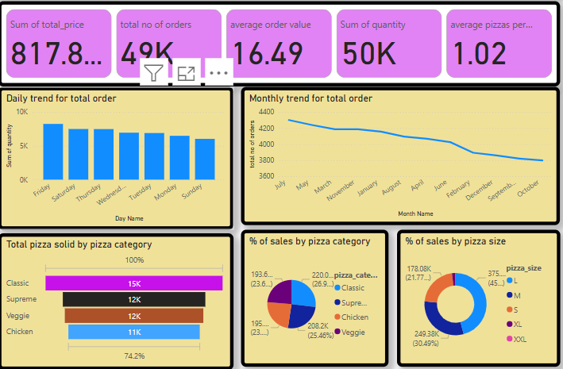

In the power bi method we followed the kpi requirement such total revenue, total orders , pizzas sold per order, average order value, these requirements we want find the result. For this requirements we use top 5 best sales and bottom 5 worst sales want to see this requirements .

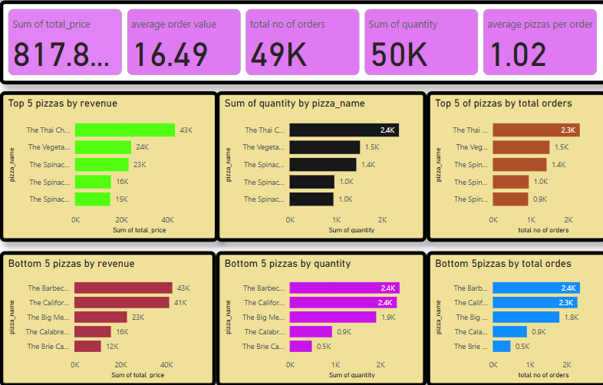

* Collected and cleaned pizza sales data from various sources .
* Analyzed data using python , sql and power bi statistical and data visualization techniques.
* Identified key trends and patterns in pizza sales.
* Developed recommendations for business decisions and sales strategies.

This project demonstrates the value of analysing pizza sales data to inform business decisions and optimize sales strategies. By leveraging data-driven insights , businesses can drive growth, improve customer satisfaction, and stay competitive in the market.

CHARTS REQUIREMENT:

WE Would like to visualize various aspects of our pizza sales data to gain insights and understand key trends. We have identified the following requirements for creating charts:

1.DAILY TREND FOR TOTAL ORDERS:

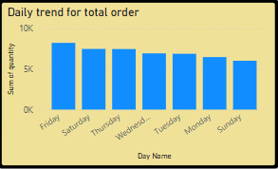 We created a bar chart that displays the daily trend of total orders over a specific time period. This chart will help us identity any patterns or fluctuations in order volumes on daily basis.

2.MONTHLY TREND FOR TOTAL ORDERS:

We created a line chart that illustrates the hourly trend of total orders throughout the day. This chart will allow you to identify peak hours or periods of high order activity.

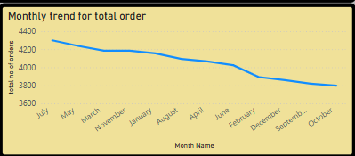

3.PERCENTAGE OF SALES BY PIZZA CATEGORY:

Created a pie chart that shows the distribution of sales across different pizza categories. This chart will provide insights into the popularity of various pizza categories and their contribution to overall sales.

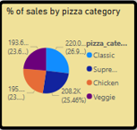

4.PERCENTAGE OF SALES BY PIZZA SIZE:

Pie chart that represents the percentage of sales attributed to different pizza sizes. This chart will help us to understand customer preference for pizza sizes and their impact on sales.

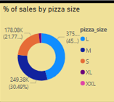

5.TOTAL PIZZA SOLD BY PIZZA CATEGORY:

Created a funnel chart that presents the total number of pizzas sold for each pizza category. This Chart will allow you to compare the sales performance of different pizza categories.

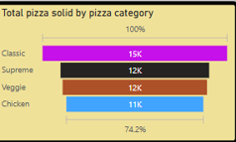

6.TOP 5 BEST SELLERS BY REVENUE ,TOTAL, QUANTITY AND TOTAL ORDERS:

Created a bar chart highlighting the top 5 best selling pizzas based on the revenue, total quantity ,total orders. This chart will allows you to identify the most popular pizza options

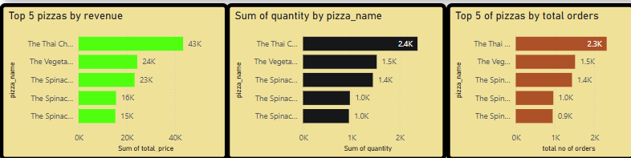

7.BOTTOM 5 BEST SELLERS BY REVENUE,TOTAL QUANTITY AND TOTAL ORDERS:

Created a bar chart showcasing the bottom 5 worst selling pizzas based on the revenue total quantity, total orders. This chart will enable us to identify underperforming or less popular pizza options.

